Design for Extra Credit Problem Day 5 (HW)
- The program is meant to simulate a bank transaction.
  - 2 bank accounts: checking and savings.
    - Ask for initial balances of the bank accounts (reject negative balances)
    - Ask for the transaction (deposit, withdrawal and transfer)
    - Ask for which account the transaction will occur in.
    - Ask for the amount, reject transactions that overdraw an account
    - Last, print the balance of both accounts.
- Examples
  - If you 700 in your savings account and 1200 in checking, and decide to transfer 100 form savings to checking, the output will be saving = 600 and checking = 1300
- Pseudocode
Define main function
Input the savings balance and reject negative values
Input the checking balance and reject negative values
Ask user for transaction (deposit, withdrawal, or transfer
For deposits:
Select account for transaction
Ask user for amount to deposit
Deposit amount to corresponding account
For withdrawal:
Select account for transaction
Ask user for amount to withdrawal (if greater than current amount then display “Insufficient funds” and display amounts in each account)
Withdraw the amount from the corresponding account

For transfers:
Select account for transaction
Ask user for amount to transfer (if greater than current amount then display “Insufficient funds” and display amounts in each account)
Transfer the amount from the corresponding account to the opposite account
After transaction:
Display the amount in each of the accounts.

- Variable(s)
  - savingsAmt and checkingAmt
  - selectionChoice (deposit, withdrawal, or transfer)
  - selectionAccount (savings or checking)
  - depositAmt, withdrawalAmt, and transferAmt
- Python Statements
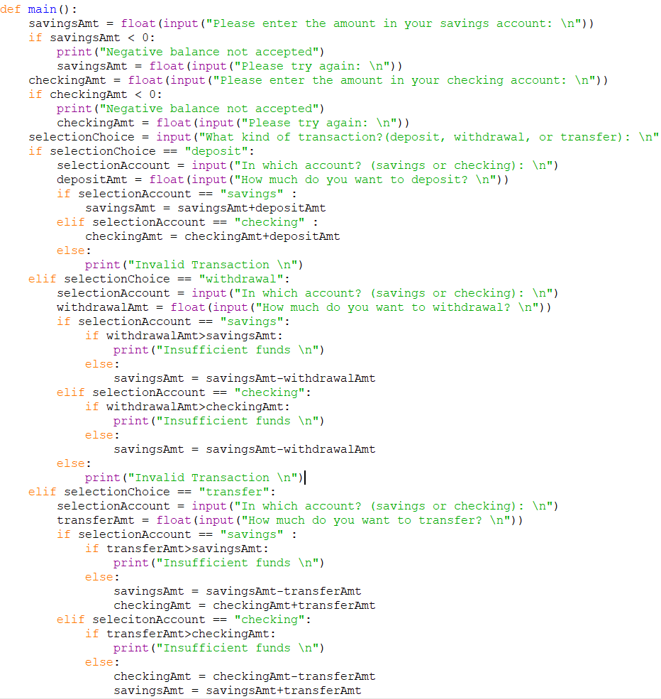
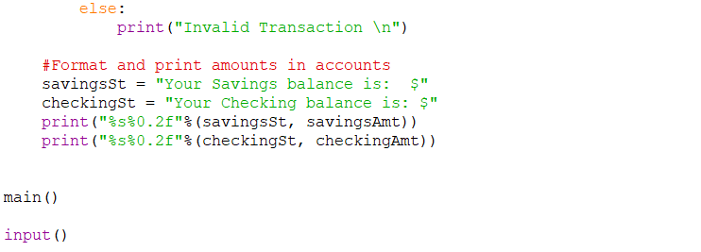
- Inputs and Outputs
  - Input –
    - savingsAmt and chekingAmt (both floats)
    - selectionChoice (string)
    - selectionAccount (string)
    - depositAmt, withdrawalAmt, and transferAmt (float)
  - Output –
    - savingsAmt and checkingAmt (floats)
- Python Code (turned in as .py file)

